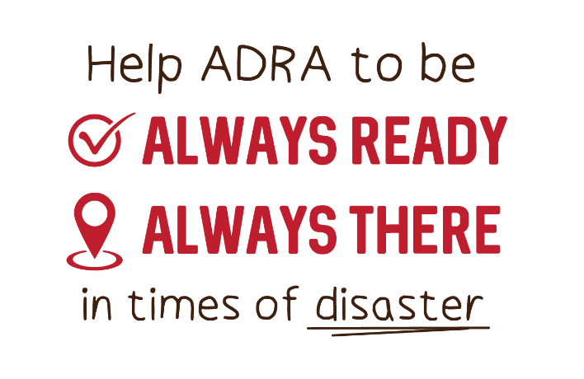
‘There will be famines and earthquakes in various places. All these are the beginning of birth pains.’ - Jesus
In Matthew 24 Jesus tells us that famine, earthquake and other disasters will increase. It’s not the way God wanted the world to be – but times of emergency are an opportunity for us to serve others just as Jesus would.
What is the Disaster and Famine Relief Offering?
The Disaster and Famine Relief Offering is an annual offering collected in Adventist Churches across the globe to ensure the Adventist Development and Relief Agency (ADRA) is there and ready to provide vital support to those affected by disasters.
How will the funds be used?
With a global presence, and strong network of projects, Op Shops and volunteers across Australia ADRA can respond quickly to disasters, providing for people’s immediate needs, while also empowering them to rebuild their lives.
The money collected during the Disaster and Famine Relief Offering help ensure there are funds immediately available for ADRA to respond to disasters as they occur. This includes providing essential items such as food parcels, hygiene packs, shelter kits and water filtration devices, while also helping communities recover in the longer-term, and be better prepared for future disasters.
How can we support the Disaster and Famine Relief Offering?
Support for the Disaster and Famine Relief Offering by:
- Giving a cash donation during the Disaster and Famine Relief Offering collection in Adventist Churches.
- Donating direct to ADRA Australia
  - Online at www.adra.org.au/respond
  - Calling 1800 242 372
  - Using the Adventist eGiving website at egiving.org.au or egiving.org.nz or on the eGiving App
Disasters, are an opportunity for us as individuals, and as a global Adventist Church to connect deeply and meaningfully with our communities – and an opportunity to show in love and action that we are there and ready to help those who need it most.
Thank you for helping people affected by disaster. For more information and offering resources visit www.adra.org.au/respond

