HOPE CHANNEL Offering – 9 April 2022

BULLETIN ANNOUNCEMENT

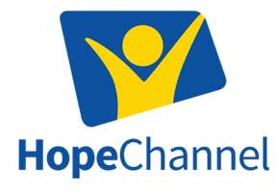

HOPE CHANNEL OFFERING ON 9 APRIL
Every day, God uses the global, evangelistic media ministry of Hope Channel to reach thousands of viewers with messages of hope and love. With 68 Hope Channels broadcasting in more than 80 languages, the mission of Jesus is being fulfilled by the power of the Holy Spirit.

Throughout these turbulent and unprecedented world events, God has used Hope Channel to beam uplifting messages directly to the screens of people across the globe. Hope at Home, a new Hope Channel program, has become the local online church service for thousands of viewers each weekend by providing inspiring messages, music, and wellness tips from professionals. You can tune in on HopeTV.org/AtHome. The Bible study platform, Hope.Study, has grown to provide free and easy-to-use Bible study courses on topics such as igniting your prayer life, navigating stressful situations, and learning to understand the Bible better. Hope Channel is also seeing more and more inspiring testimonies of viewers whose lives have been changed; you can watch these testimonies at HopeTV.org/Transformed. Thank you for supporting Hope Channel’s outreach with your offering on April 9th.

